The National

Social media is platform with pitfalls
Preeti Kannan
Last Updated: May 5, 2011
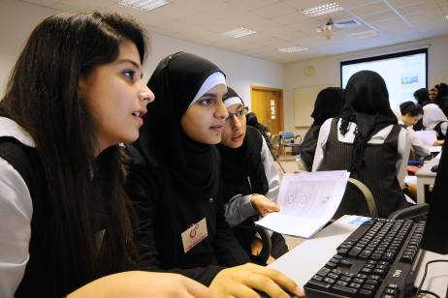
(L to R) Dana Al-Ghadi, Alaa Abdul Fattah and Alia Maker from Al-Shorouq Private School participate in an IT workshop organized by the Techno Girls at Dubai Women's College yesterday.
DUBAI // Aunoud al Jundi, a Grade 11 pupil, believes that social media provides women in the Middle East with a platform to express themselves, but at the same time she emphasized the need for using it responsibly.
"Social networking for women is good. It lets people know we have a voice and we are living. Go on to Facebook and have fun, but don't cross the line," said Aunoud, an active user.
"Everything has its advantages and disadvantages. It is not good to be adding people, especially boys, you don't know. It is also important to ensure your privacy."
Aunoud spoke after a presentation on social networking at Dubai Women's College yesterday, part of TechnoGirls, an annual event to encourage Emirati pupils to engage with technology.
The pupils, mostly Emiratis from grades 11 to 12, were warned against "friending" people they did not know and were urged to police themselves in the virtual world.
"In social networking, you are the boss and you are the police of your lives," said Sheikh Sultan Sooud Al Qassemi. "The onus is on you and you have a responsibility to the community."
Sheikh Sultan, a commentator on Arab affairs, is the chairman of the Young Arab Leaders and an active participant on Twitter, with more than 65,000 followers.
"Don't add people if you are not sure who they are," he said.
TechnoGirls is a forum that encourages Emirati girls to increase their enrolment in science, technology, engineering and maths programmes offered at the college.
The UAE is among the top 10 countries in the world in the use of Facebook, with more than 45 per cent of the population having accounts.
"The virtual world has real-world effects. We see people bullying each other and this has real psychological effects," said Sheikh Sultan, who urged pupils to be honest and respectable, protecting the privacy of others while using social media.
Rawan Gawat, from Al Thuraya Private School, decided to reactivate her Facebook profile after Sheikh Sultan's talk.
"I had created an account but deactivated it two years ago as I saw people were using it only for chatting. However, I am now excited about using it as I realise it can be used to get information and news about what's happening in the world," said the Grade 11 pupil.
But Dana Helmi, in Grade 11 at Al Shorouk Private School, was not convinced. "Social networking allows for mixing between boys and girls. Besides, it is addictive," Dana said. She added that social media could also lead to distrust between parents and children.
"I love information technology and am enjoying teaching students," said Noora Hassan, a second-year student at the college. "We are teaching them how to fix their own computers. This will save money for them."
Dr Behjat al Yousuf, the associate director at the college, said: "We want more students to come to Dubai Women's College. By hosting TechnoGirls, we aim to empower students to build successful careers for themselves and educate them on technology."

Article Report 002

Title: Social media is platform with pitfalls

Newspaper: The National

Date of publication: 5th May. 2011

Pre-reading questions:
- What did they do to improve their technologies?
- How did social media develop?
- When do will they develop the platform with pitfalls?
- Why social technologies are still at risk nowadays in private schools?

I think that this article will be about:
I think it talks about the technologies and the social media in private school. However, it has developed by companies and relating with the schools. Social media and the platforms are chosen by the developers in some companies.
Why did I choose that article?
Because I’ve think about the social media which it has, why specific in private schools not in normal schools. I mean there are few of platforms which is made it in social media in general schools. In addition, I thought general schools have more develops, but daily I want to know about the private schools and why especially them!
Summary/opinion:
Social media have been developed the women in private school. They have responsibility of doing platform. Private schools have advantages and disadvantages of adding boys with the girls. However, Emirati girls will increase as more than boys Emirati in science. They are using Facebook which are more 45 users in UAE. Finally, students to build successful careers for themselves and educate them on technology

New Vocabulary:
- Emphasized
- Ensure
- Commentator
- Enrolment
- Bullying
- empower

Additional work:

Is the same as the margin notes!

