Etisalat and du set to lock horns
Ben Flanagan
Last Updated: May 22, 2011
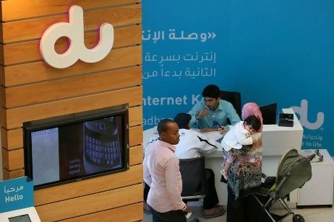

Rivalry between Etisalat and du is likely to intensify, despite the UAE telecommunications market being one of the least competitive in the Arab world.
But the UAE, which has just two mobile operators, is one of the least competitive markets, with a score of just 47 per cent, ranking it behind Yemen, Oman and the Palestinian Territories.
"The UAE is not the most competitive market," said Jawad Abbassi, the founder and general manager of the Arab Advisors Group.
"It's a duopoly market. And the two operators have a very rational, rather than a cut-throat, competition."
Mr Abbassi said the shareholder structure of Etisalat and du did not encourage stronger competition.
"They are both partly owned by government entities," he said. "When your shareholders have common interests, you're not going to have aggressive competition."
Despite this, there is still room for more intense rivalry between Etisalat and du, analysts say.
Marketing initiatives and a plan to share broadband and landline networks are likely to boost competition between the two.
"It's going to be their marketing strategy that truly differentiates them," said Philip Brazeau, who heads the telecoms practice at the Middle East law firm Al Tamimi. "Marketing is going to be critical for Etisalat to maintain its position in the market."
Some commentators say Etisalat's recent appointment of Matthew Willsher as the chief marketing officer is indicative of where its strategy may be heading.
Mr Willsher previously held the same position at Maxis Communications in Malaysia, where competition in the telecoms sector is fierce.
His appointment comes at a time when Etisalat is rapidly losing its mobile market share to du. In the first quarter, du added 272,000 active mobile subscribers, while Etisalat lost 334,000.
The Emirates's second operator du has 41.8 per cent of the mobile-subscriber market, but only 32 per cent of mobile revenue share - which could represent an opportunity for it to attract more lucrative customers, said Irfan Ellam, a telecoms analyst with Al Mal Capital.
"That implies that there is still more room for growth for them in terms of revenue," he said.
"At the moment, the growth in the mobile space is more on the data side rather than voice or SMS. In the mobile broadband space, du has a more compelling offering at the moment, but that could change."
Changes in regulation are also expected to prompt more competition between the two operators.
Matthew Reed, an analyst at Informa Telecoms & Media, said a plan for infrastructure sharing - under which both Etisalat and du would be permitted to sell landline and broadband packages across the UAE - could benefit du.
Currently, du is restricted to selling broadband and landline services to a few high-density areas of Dubai. But a plan for the two operators to share networks should enable du to compete on fixed-line services across the country by the end of the year

Article Report 002

Title: Etisalat and du set to lock horns

Newspaper: The National

Date of publication: 25th May. 2011

Pre-reading questions:
- How could Etisalat be locking the horns?
- How did du develop the set of horns?
- When did Etisalat and du set to lock horns?
- What is the reason for that?
- Why did they have to set to lock the horns?
- Is it important for that in UAE?

I think that this article will be about:
I think it talks about the technologies and the social media in Etisalat and du which means they are gathering for the Telecom.
Why did I choose that article?
Because I’ve think about the communication between Etisalat and du, also I want to know what is the deferent among them. Here is the question: which one is more relevant for communication?
Summary/opinion:
First UAE operator's hiring shows marketing strategy will be key as playing field levels off Ben Flanagan Rivalry between Etisalat and du is likely to intensify, despite the UAE telecommunications market being one of the least competitive in the Arab world. Saudi Arabia, which has four mobile operators, stands as the tightest mobile market in the region, with competitiveness score of 76 per cent, according to the consultancy Arab Advisors Group.
But the UAE, which has just two mobile operators, is one of the least competitive markets, with a score of just 47 per cent, ranking it behind Yemen, Oman and the Palestinian Territories

New Vocabulary:
- intensify
- competitive
- entities
- aggressive
- rivalry
- strategy
- lucrative
- compelling
Additional work:

Is the same as the margin notes!

