Gulf News

Dubai Police arrest gang of five suspected of million dollar robbery
Brigadier Khalil Ebrahim Al Mansouri, Director of the Criminal Investigation Department says a trap was set for the suspects
- By Dina Aboul Hosn, Staff Reporter
- Published: 14:56 April 19, 2011
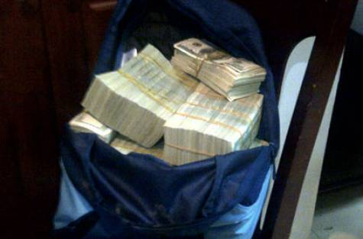
- Image Credit: Supplied
- Dubai Police announced on Tuesday the arrests of five people suspected of robbing $6 million (Dh21.6 million) from two Europeans in a knife attack
Dubai: Five people suspected of robbing $6 million (Dh21.6 million) from two Europeans in a knife attack and injuring them have been arrested, Dubai Police announced on Tuesday.
Lieutenant General Dahi Khalfan Tamim, Dubai Police Chief, said police received a report that four masked men had attacked the two victims with knives in the parking lot of their building.
The first victim sustained severe injuries, while the second was injured moderately and was able to escape his attackers. The suspects stole two bags containing the $6 million and drove away in a black car.
The victims failed to provide police with an accurate description of the car but said it was black and might have been a Jaguar.
Police launched an operation to nab the culprits under the name "Thin Thread", due to the scarcity of information and leads.
Lt. Gen. Dahi said a description of the attackers was circulated and, in coordination with security forces in the other emirates, the escape car was identified. It turned out to be the property of Australian resident A.D. and was stolen from his building's parking while he was outside the UAE on leave.
Investigations revealed the car had entered a mall and two people had exited it, and their description was circulated as well. The suspects also used another stolen car, a black Chrysler, and were very careful in their commuting and telecommunication, which showed a high degree of professionalism, the police chief said.
Brigadier Khalil Ebrahim Al Mansouri, Director of the Criminal Investigation Department (CID), said a trap was set for the suspects, by then identified as M.M. and B.K., both Russian, while they were driving the stolen Chrysler.
The two were apprehended and had Dh8,600 and $10,000 on them, and another $10,100 in the car. When their apartment was searched, police found keys and multi-purpose sharp tools.
Further investigations revealed that they knew a woman named S.F., also Russian, who lived in Sharjah and had entered the UAE immediately after the crime was committed. The gang had allegedly selected the woman to transfer the stolen money out of the UAE.
S.F. was also apprehended and searched, which revealed she had $21,000 and Dh1,872 in her possession, as well as 7,300 Russian Roubles. Upon inspecting her apartment, a sports bag containing $1,027,660 was found hidden over the false ceiling in the bathroom.
Another Russian suspect, R.A., was arrested in relation to the case and confessed that he had taken part in the crime. He had Dh3,315 in his possession.
The last suspect, J.B., another Russian, was arrested and a Mercedes car key was found with him. The car belonged to a Russian man who left the country prior to the crime. Upon searching the car, two bags were found, the first containing $2,090,100 and the second $2,400,000.
All the suspects have been referred to the prosecution.

Article Report 002

Title: Dubai Police arrest gang of five suspected of million dollar robbery

Newspaper: Gulf News

Date of publication: 19th. April. 2011

Pre-reading questions:
- When this crime was happened?
- How this problem will affect in Dubai?
- What kind of people did the steal this money?
- Why Dubai only have a lot of crimes in the UAE?

I think that this article will be about:
I think it talks about people who did steal a lot of money in Dubai. After they did steal the money they travelled to another country. This article talks about the crime in Dubai general crimes.
Why did I choose that article?
I want to see why only Dubai has a lot of crimes. Is it the reason is why there is much money to steal and doesn’t have any protection. Another reason for choosing this article is why the crimes only happened in Dubai, and why those people steal this money? Actually, what do they want for this money to do on it?
Summary/opinion:
There are five people who stole a lot of money round 21.6 DHS in Dubai. Two of them are from European countries and the others are from Russia. However, some of them tried to travel to their country but before that the police arrested them because they are facilities of this crime in stole 6 million dollars.

New Vocabulary:
  - suspected:
  - victim:
  - sustained:
  - culprit:
  - circulated:
  - revealed:
  - apprehended:
  - inspecting:
  - prosecution:

Additional work:

Outline
Intro: Five people have been arrested because they stole a lot of money which it’s round 6 million dollars.
Body 1: Two of them are from European they have the Victims and knives and the 6 million dollars and tried to get to the black car.
Key point: To provide police with an accurate description.
Key point: has the scarcity with the Police.
Body 2: The others stole about 10,000 Dollars and they are from Russia, but those travelled to their.

Conclusion: The police in Dubai caught them and arrested them on Monday also from Russia and European countries.

