The National

Abu Dhabi's airline Etihad lands first profit on course for break-even

By Mohammed Al-hammadi
Last Updated: Apr 20, 2011
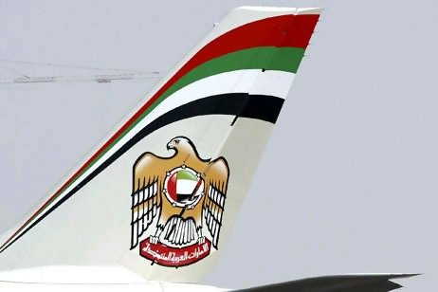

Etihad Airways recorded its first operating profit in the first quarter, putting it on track to achieve its target of breaking even this year and making a profit next year.
Revenue surged to US$770 million (Dh2.82 billion) for the quarter, 21.2 per cent higher than the same period last year.
The positive results came despite a period of heavy instability in the global economy, with shocks coming from the Japanese earthquake and nuclear crisis, unrest in the Middle East and North Africa and severe cold weather in Europe early in the year.
The Abu Dhabi airline did not disclose how much it earned in the first quarter but said the performance was helped by reducing its operating costs by nearly 6 per cent and achieving increasing efficiencies through steady expansion.
"It is a good start to the year and we are heading in the right direction," said James Hogan, the chief executive of the 7-year-old airline.
The first quarter is one of the slimmest business periods for Middle East airlines, so Etihad's positive results will give the airline momentum as it heads into the busy summer season, in which Gulf residents often travel to distant destinations for holidays to avoid the hot summers at home.
The airline's passenger revenue rose 15 per cent on the back of a 10.6 per cent growth in passenger numbers to 1,854,392 travellers.
Mr Hogan said the airline was benefiting from growing brand awareness, a maturing route network and the partnerships it has forged with 30 other airlines.
The numbers did include some declines. Etihad's percentage of seats filled fell to 72.7 per cent in the first quarter from 75.1 per cent in the same period last year, due to the impact of Middle East unrest and the Japanese earthquake.
The airline's first-quarter cargo revenue grew by 44 per cent year-on-year. Capacity grew by 22 per cent in the same period, Etihad said.
Last month represented Etihad Crystal Cargo's best in revenue, number of shipments and tonnage carried, due to growing business from China and India.
Economic forecasts suggest the air travel market remains at risk from the regional crises.
"The next few months at least will see air travel adversely hit by a further surge in fuel prices and unrest in the Middle East and North Africa, the impact of the Japanese earthquake and a fall, hopefully temporary, in business confidence during March," the International Air Transport Association said yesterday.
"Most economic forecasts see these as temporary setbacks to continued expansion. If so, travel growth should resume."
Etihad insulated itself against the oil price rise related to unrest in the region.
It bought more than 75 per cent of its fuel last year at lower prices, Mr Hogan said.
Etihad is a key driver of the Abu Dhabi economy and has been mandated not only to become profitable but also to contribute to the emirate achieving its 2030 development plan.

Article Report 002

Title: Abu Dhabi's airline Etihad lands first profit on course for break-even

Newspaper: The National

Date of publication: 20th. April. 2011

Pre-reading questions:
- What did they do to improve their company?
- How it rated with the world with profits?
- When Abu Dhabi Etihad airline profit on course?
- Why Etihad line only the airlines in the world was chosen?

I think that this article will be about:
I think it talks about how the Etihad airways profit or cost their compant into the whole world. And I think it comparing as what happened as between last year and this year. In addition, how the Earthquake in Japan where it was happen in March, 2011 affected with Etihad Company.
Why did I choose that article?
Because I’ve just want to know what happen in Etihad in every year. This information about Etihad Company will help me to attend with them in the future after I graduate from the University.
Summary/opinion:
Etihad airways are the first airline profit this year and the next year will be in the first quarter. It takes positive way profit in this year and how about next year after the Earthquake affected in Japan. This year, Etihad Company growth for the passengers to travel around the world approximately 2 million passenger. Next 2 months will see Etihad Company will grow due to Middle East and India. I think Etihad Company has positive way for the access because it’s a big company in the world from the UAE.

New Vocabulary:
- instability
- performance
- efficiencies
- expansion
- slimmest
- distant
- shipment
- insulated
- mandated
Additional work:
No need for outline for this article, because it’s almost known in the world about Etihad Company.

